Introduction
The USRP N200 SDR, provided by Ettus Research, is a white box with a lot of DSP magic. This documentation provides some loose instructions on troubleshooting (on the software level) the USRP N200 SDR that we will be working with.
The laptop that accompanies the ground station is an HP EliteBook, with a Fedora 39 operating system, for compatibility with the software dependencies. The software we use is called GNURadio and GQRX. GQRX can be installed from the software “store” that the OS provides. The SDR requires a specific software dependency called UHD, which may need to be installed separately.
It is important that this laptop has a direct connection to an ethernet cable, as that is the only possible output for data from the SDR. According to documentation, a USB to ethernet adapter can cause data transmission issues. The ethernet cable must have at least 1GB/s capability, and the chips inside the SDR will refuse to connect if it senses a lower-speed cable.
Upon connection of the power cable, RF ports, and ethernet cable, we must test a connection to the laptop by pinging the device. Open the terminal, and type:
ping 192.168.10.1
ping 192.168.10.3
If no responses are received on either of these attempts, you must perform some troubleshooting as shown below.
Software Troubleshooting
Because we are working through an ethernet port, we must make sure that we set a static IP address on the laptop, as well as a subnet mask. Below you will see the networking section of the USRP2 manual for N2XX devices.
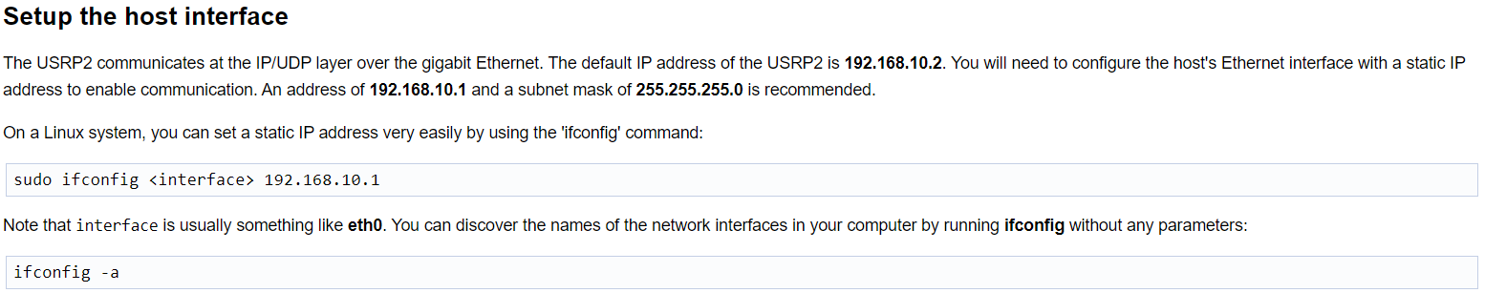

After ensuring all connections on the SDR and powering it on, run the following command:
ifconfig -a
Now, look for the interface titled “enp0s31f6”. This is the ethernet connection and is to be entered in the <interface> field above when executing that command. However, the command is not complete, as we also need to set the appropriate subnet mask. The full command is as follows:
sudo ifconfig enp0s31f6 192.168.10.1 netmask 255.255.255.0
You will be prompted to enter the password, which is the same as the password to log in to the laptop.
After this, try again to ping the device, which should respond to pings on 192.168.10.1 and 192.168.10.3 IP-addresses. If still no pings are returned, you may need to run the usrp2_recovery.py program, found in the SDR utilities folder in the Desktop. Open the folder where the file is located, right click and select “Open in Terminal”. Then run the following command:
sudo python usrp2_recovery.py –ifc=enp0s31f6 –new-ip=192.168.10.1
Again, you will be asked for a password. If you pay close attention to the where the manual covers this, you will see that this file is provided in the uhd utilities directory, however this program no longer runs properly because it was built for python 2, and we have python 3 installed. This file was downloaded from the updated UHD github repo: https://github.com/EttusResearch/uhd/blob/master/host/utils/usrp2_recovery.py
Hopefully now when pinging the device, it will respond. If not then idk… Google is your friend, as it was mine.
Use of GQRX
Upon successful pings to the SDR, you may now run the GQRX software, which can be accessed by the OS search bar or by simply typing “gqrx” into the terminal. A small device configuration window will open up, where you may have to do a device scan to find the SDR. Then you can open the software and start looking for signals!
This section will continue to get updated as I get accustomed to the software and learn its ins and outs.

Additional Resources
When learning how to use the SDR, I found the following resources helpful:
General manual: https://files.ettus.com/manual/page_usrp2.html
UHD installation: https://files.ettus.com/manual/page_install.html

Written by Jay Williams, Ground Station Project Lead ’23, ‘24

